Does an ice cube melt faster in hot water or cool water?

Research by: Wuttisak Praporn

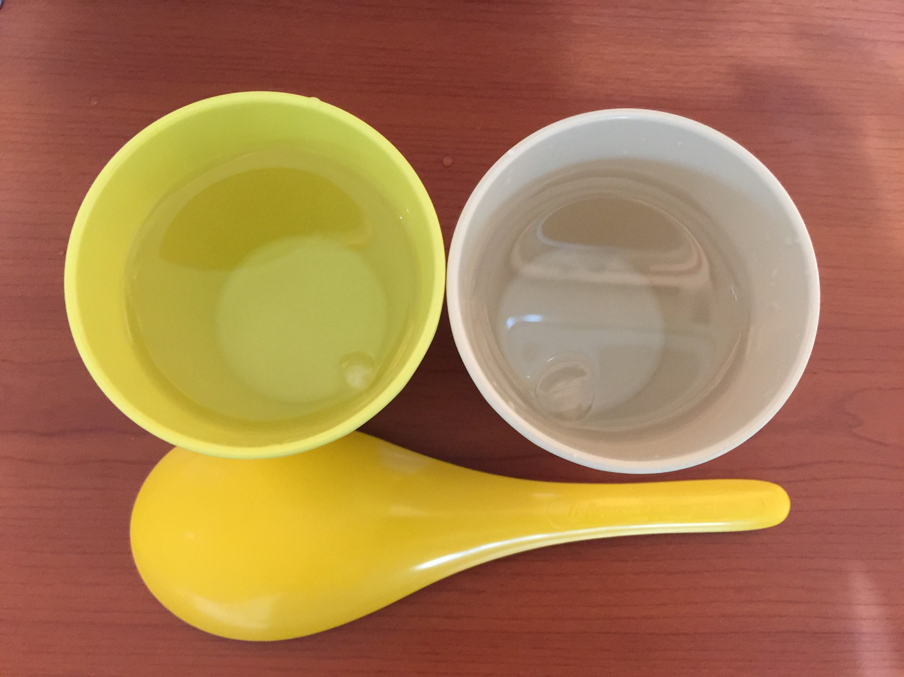

I. Introduction
Question/Problem: Does an ice cube melt faster in hot water or cool water?

Hypothesis: Yes, ice cube melts faster in hot water than in cool water.

Variables:
- Independent Variable: water temperature
- Dependent Variable: time taken to melt the ice cube
- Controlled Variable: amount of water, the size of the ice cube, the type of containers, etc.

III. Methods
Materials:
- 1 piece of plastic spoon
- 6 cubes of ice
- 2 plastic cups
- eresable marker
- cool water from the tap
- hot water from the water dispenser

Safety Rules:
- Avoid spilling the water
- Be careful of hot water

Procedure:
Step 1: Design a table for your data record
Step 2: Label the two cups hot and cool
Step 3: Pour 50 ml of tap water in in cool cup
Step 4: Prepare your stopwatch
Step 5: Using the plastic spoon, add 1 cube of ice in cool cup, and start the time.
Step 6: Observe and record results
Step 7: Repeat the steps 3 times.
Step 8: Follow the same steps in 1-7 by using hot water.

IV. Results

Table 1. Shows the results of time taken for the ice to melt in cool water and in hot water.

Water Temperature | Time Taken for the Ice to Melt
 | Trial 1 | Trial 2 | Trial 3 | Average
Cool water | 5 min 30 s | 5 min 45 s | 5 min 20 s | 5 min 32 s
Hot Water | 2 min 10 s | 2 min 0 s | 2 min 20 s | 2 min 10 s

Discussion:
Table one data results shows the comparison of the time taken for the ice to melt in a cool water and in a hot water. The average time taken to melt the ice in cool water is 5 minutes and 32 seconds. While, the average time taken to melt the ice in the hot water is 2 minutes and 10 seconds. This result shows a difference of 3 minutes and 22 seconds for ice to melt between cool and hot water.

V. Conclusion, Recommnedation…

Conclusion:
Based on the results of the experiment, there is a significant difference of time taken to melt the ice cube between cool water and hot water. It shows that the hot water melts the ice cube faster than the cool water. Therefore, the hypothesis is accepted.

