Does Spoken Words Affect the Growth of Plants?

Triamudomsuksa Pattanakarn School
English Program, M3 Students

Science Fair Project, July 7, 2016

Presented By:
Pimchanok Charoenduaisiri
Varawan Kamthongvijit
Akrima Roongkwansiriroj

ABSTRACT
Growing healthier plants is an everyday challenge for farmers and agriculturists. There are many factors that affects plants’ growth. The amount of sunlight that the plant receives and the amount of water and minerals in the soil that the plant takes are one of the vital factors that affects the growth of the plant. In some recent studies, there are some few researchers who considered sound wave or vibration as a factor of affecting plant growth. Music is one of the examples of the experiments that they are doing to examine if it really affects the growth of plant. Meanwhile, there are also scientists who study about water affected by words and scientists who developed the so called “water memory theory”. In this aspect, we, as student researchers hypothesized that plant is affected by sound wave such as music or spoken words not because plant is capable of hearing and understanding the message, since plant proven not to have brain organs, but plants is made up of as much as 90-95% water. This fact is very relevant and would support our hypothesis.
Every word and action of us affect our surroundings. There are some groups of people who exercise regularly, eat healthy food, and no predecessor had gotten a heart disease got a heart disease because of harsh words from his or her family member or relatives. Our words take a huge role in people’s mental and physical health, similar probably on plants. So, in this experiment, we are going to test out that does our words affect the growth rate of the plant. This may be the huge factor that helps plants grow well that we overlook and may contribute help to our community especially in the agriculture ascpect and people who loves to domesticate plants.

Chapter 1
Introduction

Background Research and Concept
Through the 1990’s, Dr. Masaru Emoto performed a series of experiments observing the physical effect of words, prayers, music and environment on the crystalline structure of water. The result was that we always observed beautiful crystals after giving good words, playing good music, and showing, playing, or offering a pure prayer to water. On the other hand, we observed disfigured crystals in the opposite situation. From this, we can conclude that words, prayer, music and environment affect how the molecules in water form. Good words, prayer, music, and environment make the molecules in water well-organized and causes beautiful crystal while bad words, prayer, music, and environment causes an opposite outcome.
Plants are composed of water, carbon-containing organics, and non-carbon-containing inorganic substances such as potassium and nitrogen. But the majority of the volume in a plant cell is water; it typically comprises 80 to 90 percent of the plant's total weight. Soil is the water source for land plants. Plant roots absorb water from the soil through root hairs and transport it up to the leaves through the xylem. As water vapor is lost from the leaves, the process of transpiration and the polarity of water molecules draws more water from the roots up through the plant to the leaves. Plants need water to support cell structure, for metabolic functions, to carry nutrients, and for photosynthesis.
Water is used in every single parts and steps by the plant as it was written above. We think that plant having water with well-organized molecules will help plants to grow well, and speaking good words make a well-organized molecules in water. So, we are going to conduct an experiment to figure out that does good words and bad words affect the growth rate of the plant.
Objective of the Study
To figure out does good words and bad words affect the growth rate of the plant
Benefits of the Study
- To improve the growth rate of the plant
- To produce a healthier plant
Hypothesis
We hypothesize that speaking positive words to the plant makes it grow faster and healthier.

Scope and Limitation of the study
- The words that will be spoken will be in Thai language.
- The positive and negative words will be written in script.
- The plant that will be used in this experiment is raw mung bean.
- The experiment will be done in 3 days.

Chapter 2
Literature Review
21 years later after the shocking news of the scientists were dead because of just ordinary water, Masaru Emoto, a Japanese researcher, did an experiment and proved that human consciousness has an effect on the molecular structure of water. In 1977, he did an experiment about water has memory. He placed rice in three beakers. He always say thank you to the rice in beaker A, in beaker B he always talk to them rudely like “you’re idiot” to them, and in beaker C he ignored them. One month later, the rice in beaker A being fermented aromatically, but the rice in beaker B turned black, and the rice in beaker C became rotten.
Emoto also did another experiment; he took water samples from around the world and put that water into one hundred petri dishes and assigned each dish a fate: good or bad. The good water was blessed or praised for being so wonderful. They played good music, and showing, playing, or offering pure prayer to water. The bad water was scolded. Not just only that, they also spoke harshly to them. Each petri dish was frozen, allegedly under similar conditions. When the frozen water was viewed under a microscope, the water which had been praised and valued had rearranged itself into beautiful crystalline structures. The “bad” water was in ugly structures, showing a lack of proportion and more overall roughness. This experiment shows that the good words and bad words can affect the water’s structures.
Water memory is the ability of water to memorize the substances (solute) that dissolved in it even there’s no molecule of any active substances remains in the final product.
This theory was first proposed by the late French biologist and immunologist, Dr. Jacques Benveniste. But why is that? Water doesn’t have any brain or organs that can remember actions and other things. The experiment they’ve tried is putting different flowers is each jar of water. Then get some examples of the water in the jar and see if what molecules looks like. The surprising thing is each jar’s water has different appearance. But when we swap the jar and put the flower down again, the appearance changes as the first time. So, people are questioning if the water has the memory of remembering the kind of the flower so it does change the molecule’s appearance. He and his team also did another experiment. They diluted a solution of human antibodies in water to such a degree that there was no possibility that the antibody remained in the water solution. However, the experiment shows that the human basophils (type of WBC) responded to the solutions just like they there are the original antibody. At that time, Benveniste didn’t offer any theoretical explanation for the effect, but it was later called "water memory" by a journalist reporting on the study.

After Benveniste died, Luc Montagnier took up this. In his experiments, he tested by brought a fragment of HIV DNA was taken from its long terminal repeat and used for generating EM signals, and electromagnetic background was detected. At that point, the tube containing pure water also emits EM signals at the dilutions corresponding to those giving positive EMS in the original tube. This transmitting takes about 18 hours.
Water has ability to reproduce the properties of any substance it contains. Water would have ability to retain the memory of the molecules properties.

The leaves of the plants can show the health of the plants. General yellowing of plant shows that it has low fertility of soil or the temperature is too high. Young leaves that are yellow show that it has low light intensity or iron or manganese deficiency. Old leaves those are yellow means nitrogen, magnesium or potassium (major elements) are not enough. Yellow round spots on leaves show that there are fungal, bacterial or virus infections. Dead or yellow irregular spots or flecks means that Pesticide damage is happen. Mosaic pattern of light and dark green, the plants have virus infection. Leaves with abnormal color pattern will happen when it has mutation in small area of tissue. Leaves very dark green with water soaked or limp appearance show that there’re bacterial infection. Leaf tips and margins dead mean underwatering or pesticide damage, etc.

CHAPTER 3
Methodology

This part includes the description of research design, the materials, apparatus, and procedure used in the experiment. This part also includes the statistical treatment of data.

Research Design:
In this study, the group researchers used experimental research design. The experimental research variables are the following below:
- Independent Variable: The positive and negative words spoken to raw mung beans or (Vigna radiata)
- Dependent Variable: The growth of plant
- Control Variables: water, place of growth, the time we speak to the beans, amount of water, amount of the mung bean, number of days
Materials:
- Some cotton ( we used facial cotton swabs )
- 27 raw green beans ( mung beans )
- Water
- Graphing Paper
- Ruler
- Marker
Apparatus:
- 9 beakers
- Dropper

Procedure:
- Prepare 3 groups of beakers and label them (see table below).

GROUP OF BEAKERS | NUMBER OF BEAKERS
Group A: | Three beakers: 1A, 2A, 3A
Group B: | Three beakers: 1B, 2B, 3B
Group C: | Three beakers: 1C, 2C, 3C

- Place the test tubes in a separate test tube racks according to their group
- Place the same amount of cotton at the bottom of the beakers and put three raw mung beans in every test tube.
- Using a dropper, wet the cotton with the same amount of water which is 10 ml.
- Place them in the experimental room with an average room temperature.
- Separate the three groups in the room approximately 5 to 7 meters distance. Make sure they are exposed to a similar amount of light (sunlight or artificial light or no light at all during nightime).
- Choose one person in the group to initiate the manipulated or independent variables to plant A and B.
  - Plant A: Speak positive words to plant A for 5 minutes; once in the morning and once time in the evening for 3 days.
  - Plant B: Speak negative words to plant B for 5 minutes; once in the morning and once in the evening for 3 days.
  - Plant C: Do not speak any words.
NOTE: Do not touch the mung beans for three days and when you speak do not speak inside the container because the air from your mouth will be a factor to affect your plant growth. Speak through the glass since sound energy can pass through.
- For three days, observe the growth or any changes of mung beans.
- Water the plant moderately and regularly with the same amount10 ml, once in the morning and once during the night.
- Take photo and record the results.
- After three days, remove the mung beans carefully from the beakers.
- Measure the length of the stems using ruler and thread, diameter of the stems using vernier caliper, the area of the leaves using graphing paper, the number of leaves, and the color of the leaves.
- Obtain the final results.

Statistical Treatment of the Data:
The following data results such as; the length of the stem, the numbers of leaves, the size of leaf (leaf area) and the number of greener leaves will be analyzed by getting its mean or average.
The qualitative measurement of leaf color will be analyzed using Likert Scale.
The five point Likert Scale.
Scale Numerical Value Descriptive Value
5 4.21 – 5.00 Dark Green
4 3.41 – 4.20 Normal Green
3 2.61 – 3.40 Light Green
2 1.81 – 2.60 Yellowish
1 1.00 – 1.80 Yellow Brown

CHAPTER 4
Data Analysis

- The pictures showing the growth of plants in day 1 and day 2
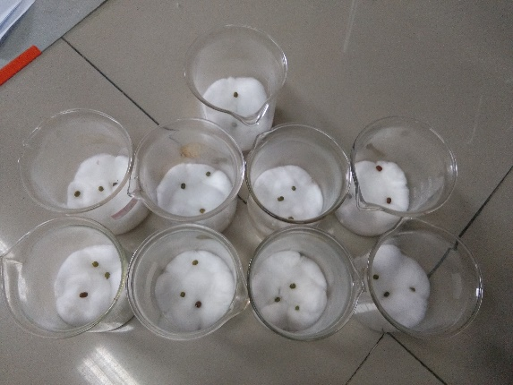
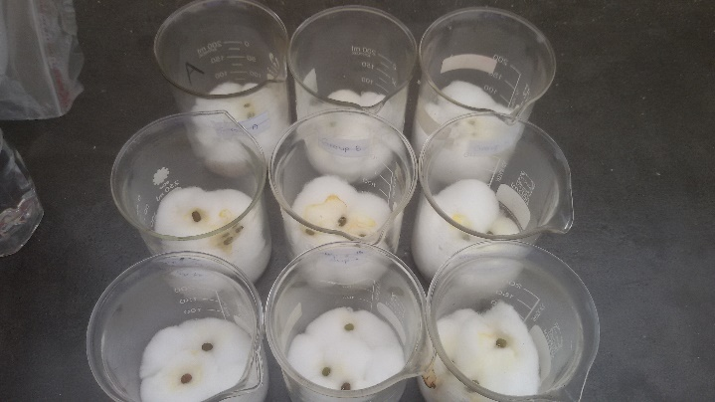

Day 1 Day 2

Day 1 Day 2

- Graph shows the rate of growth of the mung beans

Height (cm)

Data Results
The result of the experiment
- Average growth per day
Day\Beaker | A | B | C
Day 1 | 0 | 0 | 0
Day 2 | 1 | 0.3 | 0.6
Day 3 | 2.2 | 1 | 1.5
Day 4 | 3.2 | 1.6 | 2.5
**All results inside the table are the length of the stem in cm.
- Leaves of the beans
Day\Beaker | A | B | C
Day 1 | 0 | 0 | 0
Day 2 | 1 | 0 | 0
Day 3 | 2 | 1 | 1
Day 4 | 2 | 1 | 2

CHAPTER 5
Summary, Conclusion, Recommendations
Summary

Conclusion
The plant that had been spoken with the good word grew better than the plants with the bad words no words spoken. So, the result of the experiment shows that the words that have been spoken to the plants have effects on the growth rate of the plant.
So, our hypothesis that we have predicted is correct and we could use this experiment’s method and result to use in daily life such as planting the bigger plant, which it’s going to help your plants grow faster.

Recommendation
We should plant those plants in the place where has the same temperature all day. Also, we should place the plants somewhere that is absolutely no sound to make it has he least effect to the plants.

REFERENCES
- Source: Boundless. “The Chemical Composition of Plants.” Boundless Biology. Boundless, 26 May. 2016. Retrieved 26 Jun. 2016 from https://www.boundless.com/biology/textbooks/boundless-biology-textbook/soil-and-plant-nutrition-31/nutritional-requirements-of-plants-186/the-chemical-composition-of-plants-710-11934/

- http://www.masaru-emoto.net/english/water-crystal.html

- Thinstock, Hemera (2012).Talking to plants.Mythbusters: https:\\www.discovery.com/tv-show/mythbusters/mythbusters-database/talking-to-plant/

- http://rationalwiki.org/wiki/Water_memory

- http://highexistence.com/water-experiment/

